**Sacrament of Reconciliation**

Throughout the year Saturdays 11:00 a.m.-12:00 p.m.  
Twenty minutes before each weekday Mass  
or upon request

**Please note:**

1) **Good Friday** is a day of fast and abstinence (no meat).

2) **Blessing of Easter food** will take place in the church on Holy Saturday afternoon, April 20, at 12:30 p.m. In some cultures people prepare a basket of special foods (for example, meat, bread, dairy foods, eggs, cakes and pastries, wine) that will be shared at their Easter dinner. These are blessed, symbolic of the desire of Jesus to share a meal with us.

3) **On Easter Sunday** an addition to the regular Sunday Mass schedule is required to accommodate the large crowds and to reduce congestion in the parking lot. An extra Mass will be celebrated on Easter Sunday at 7:30 a.m. Please consider coming to this Mass. The complete schedule for Easter Sunday appears on the opposite side of this page.



**Schedule of Holy Week Liturgies  
(The Triduum)**

**Holy Thursday, April 18**

1. 7:30 p.m. Mass of the Lord’s Supper
2. The church will be open until 10:00 p.m. as we keep watch in prayer in the spirit of Gethsemane. Adoration of the Blessed Sacrament ends at 10:00 p.m.
3. 10:00 p.m. Night Prayer

**Good Friday, April 19**

1. 11:00 a.m. Celebration of the Passion of the Lord
2. 3:00 p.m. Celebration of the Passion of the Lord

**Holy Saturday, April 20**

1. 8:00 p.m. Easter Vigil
2. This beautiful and symbol-filled liturgy provides all with the opportunity to reflect on God’s presence with us from the beginning of time. The blessing of the Easter fire and lighting of the Paschal Candle, and the blessing and sprinkling of the Easter water, are direct, living reminders of the miracle that is Easter. Consider attending especially if you have never been before.

**Easter Sunday, April 21**

1. 7:30 a.m. Easter Mass
2. 9:00 a.m. Easter Mass
3. 11:00 a.m. Easter Mass

|  |
| --- |
| **Easter Collection** |

May your Easter offering reflect  
the generosity of God’s love for you.

|  |
| --- |
| **Easter Alleluia** |

Following the liturgy on Holy Saturday evening,   
all are invited to the “Easter Alleluia” reception  
in the church hall.



May God bless you at Easter  
with renewed hope, joy and love  
and may the Spirit of the Risen Christ  
live within you now and always.

A Blessed and Happy Easter to all!

Fr. Rafal Tomon, Pastor

He is risen!

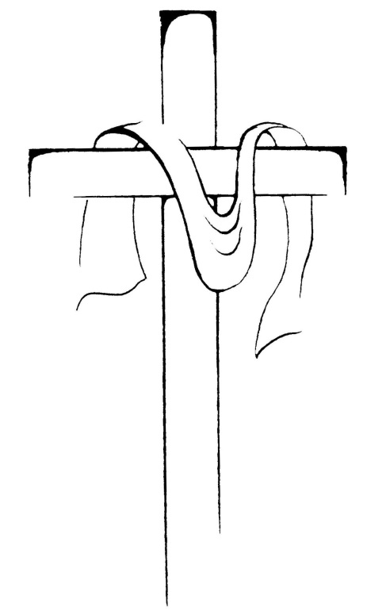

Alleluia!

Alleluia!

Alleluia!

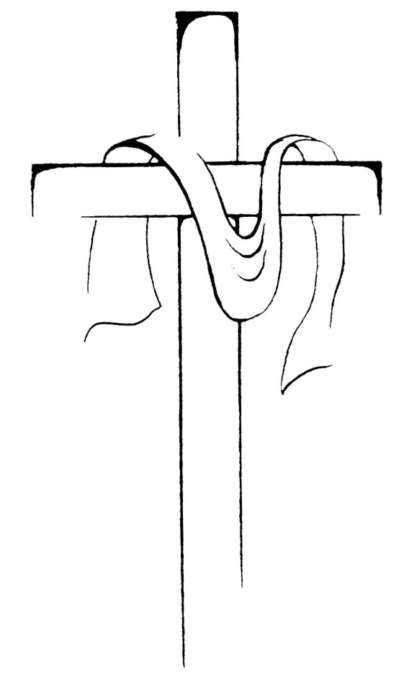



Holy Week Schedule  
2019

Our Lady of Lourdes Church

Waterloo, Ontario