**Sacrament of Reconciliation**

Throughout the year Saturdays 11:00 a.m.-12:00 p.m.  
Twenty minutes before each   
weekday Mass or upon request  
Thursday, April 7, 2022… 6:00 p.m. – 7:00 p.m.

**Please note:**

1) **Good Friday** is a day of fast and abstinence (no meat).

2) **Blessing of Easter food** will take place in the church on Holy Saturday afternoon, April 16, at 12:00 p.m. In some cultures people prepare a basket of special foods (for example, meat, bread, dairy foods, eggs, cakes and pastries, wine) that will be shared at their Easter dinner. These are blessed, symbolic of the desire of Jesus to share a meal with us.

3) **On Easter Sunday** an addition to the regular Sunday Mass schedule is required to accommodate the large crowds and to reduce congestion in the parking lot. An extra Mass will be celebrated on Easter Sunday at 7:30 a.m. Please consider coming to this Mass. The complete schedule for Easter Sunday appears on the opposite side of this page.

 **Schedule of Holy Week Liturgies  
(The Triduum)**

**Holy Thursday, April 14**

1. 7:30 p.m. Mass of the Lord’s Supper (live stream)
2. The church will be open until 9:00 p.m. as we keep watch in prayer in the spirit of Gethsemane. Adoration of the Blessed Sacrament ends at 9:00 p.m.
3. 9:00 p.m. Night Prayer

**Good Friday, April 15**

1. 11:00 a.m. Celebration of the Passion of the Lord
2. 3:00 p.m. Celebration of the Passion of the Lord (live stream)

**Holy Saturday, April 16**

1. 7:30 p.m. Easter Vigil (live stream)
2. This beautiful and symbol-filled liturgy provides all with the opportunity to reflect on God’s presence with us from the beginning of time. The blessing of the Easter fire and lighting of the Paschal Candle are direct, living reminders of the miracle that is Easter. Consider attending, especially if you have never been before.

**Easter Sunday, April 17**

**On Easter Sunday** an addition to the regular Sunday Mass schedule is required to accommodate the large crowds and to reduce congestion in the parking lot. An extra Mass will be celebrated on Easter Sunday at 7:30 a.m. Please consider coming to this Mass.

1. 7:30 a.m. Easter Mass
2. 9:00 a.m. Easter Mass
3. 11:00 a.m. Easter Mass (live stream)

|  |
| --- |
| **Easter Collection** |

May your Easter offering reflect  
the generosity of God’s love for you.

|  |
| --- |
| **Easter Alleluia** |

Following the liturgy on Holy Saturday evening,   
all are invited to the “Easter Alleluia” reception  
in the church hall.



***May you joyously celebrate***

***the sunrise victory of Easter***

***in whose glorious light***

***God revealed***

***our final achievement,***

***our own resurrection.***

**A Blessed and Peaceful Easter to all!  
with prayer, Fr. Rafal**

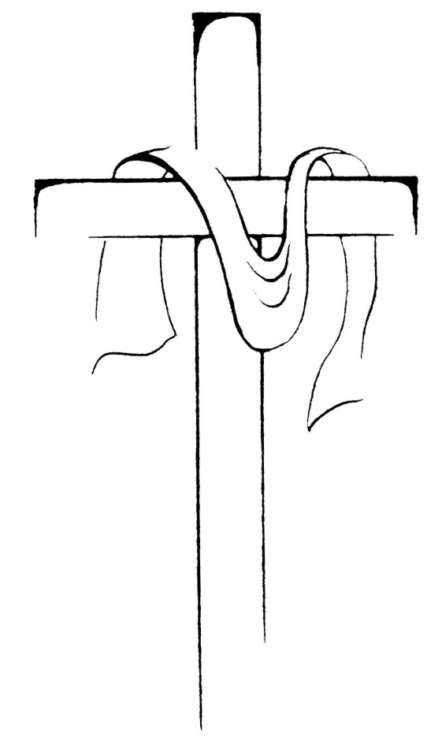



Holy Week Schedule  
2022  
Our Lady of Lourdes Church

Waterloo, Ontario